How to check memberships
- Start on your club/ society webpage.

- Page Admin > Society admin tools
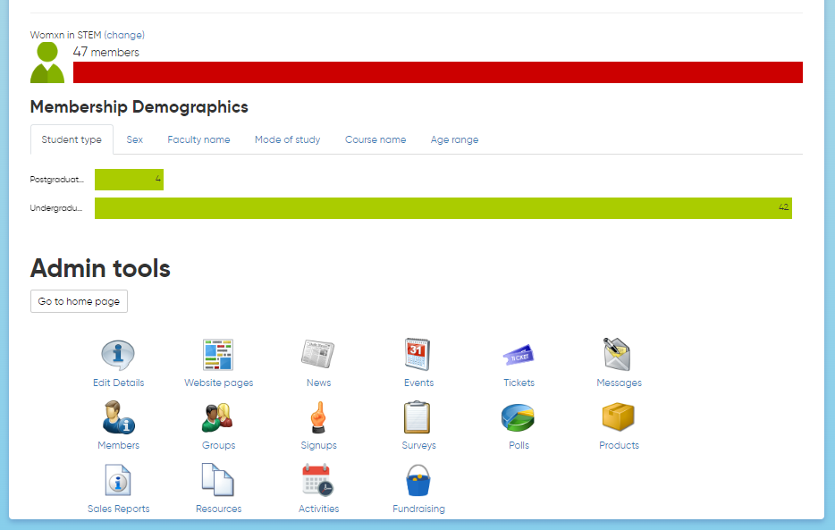
- Members

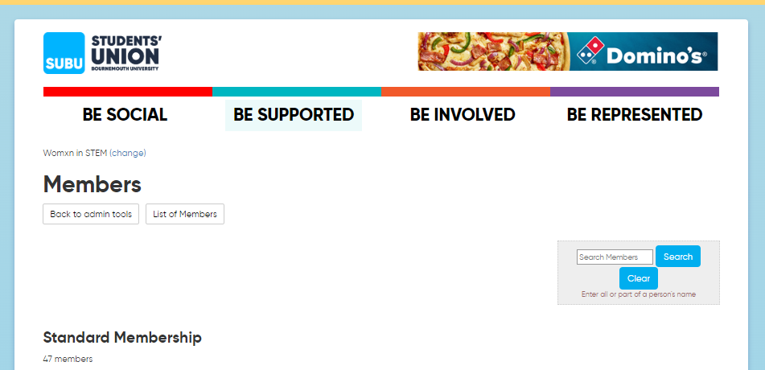
- You will then need to click ‘List Members by Group’ to distinguish who has bought the Standard Membership and who has purchased the Associate Membership. Please remember that committee members must also buy their Standard Memberships!

