Editing Your Club page

1. **Start on your club/ society webpage.**
2. 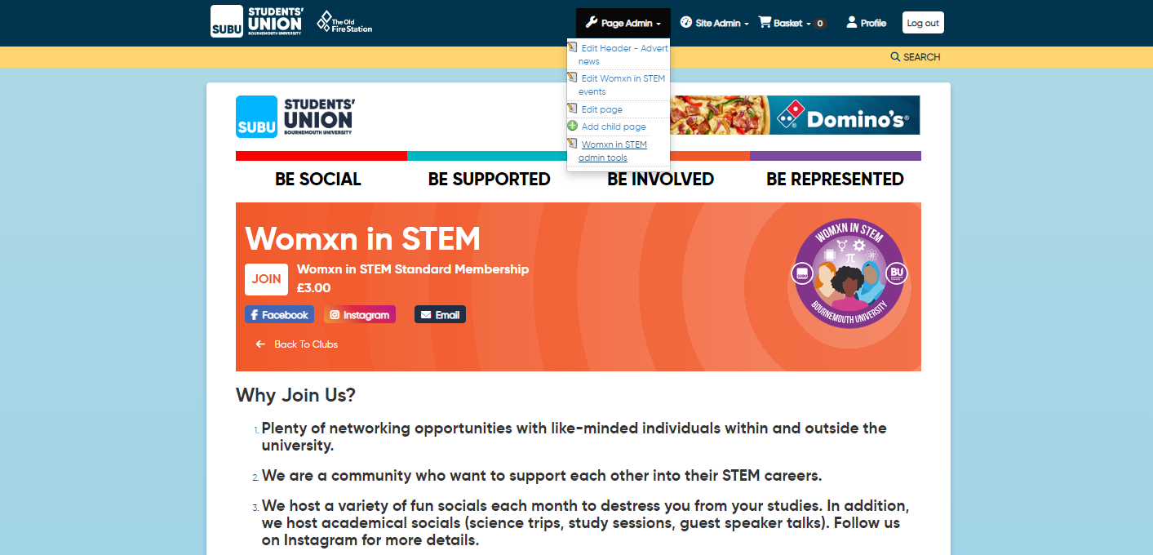**Page Admin > Society admin tools**
3. 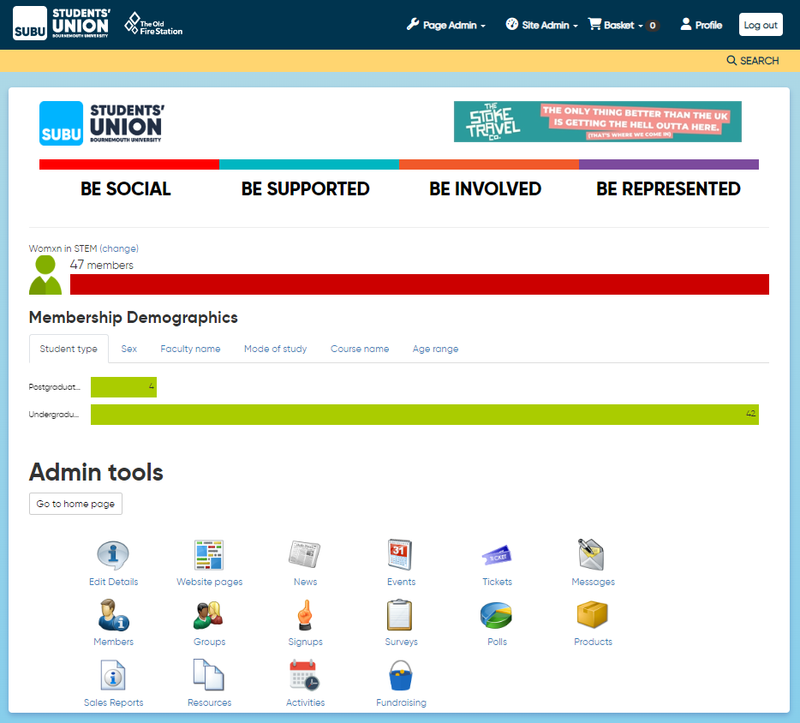**Edit details**

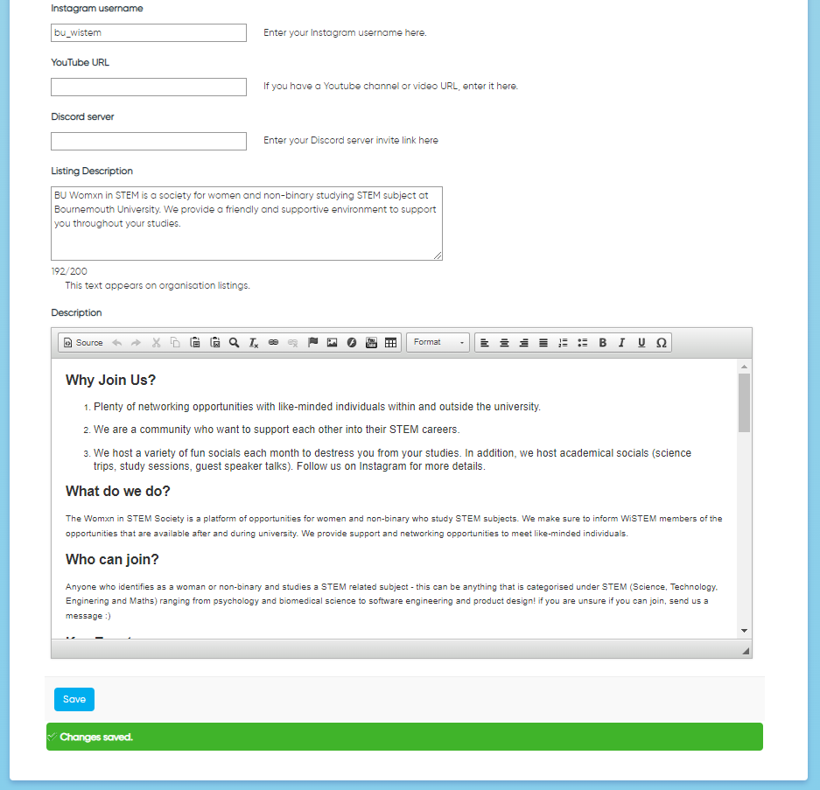

**Remember to click SAVE**